
SPECIALIST MATHS
TRIAL EXAMINATION 2
2003
SOLUTIONS

_____________________________________________________________________

Question 1
a. i. 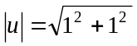
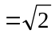 (1 mark)

- Method 1
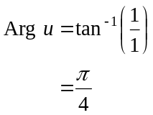
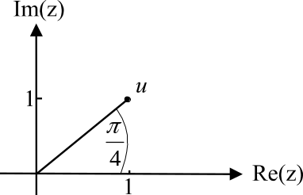
(first quadrant)

Method 2
From the diagram,
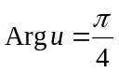 (1 mark)

- Multiplying a complex number by i has the effect of rotating it in an anticlockwise direction by 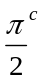. So, start at u and after 5 anticlockwise turns of 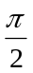, you land at w as shown.
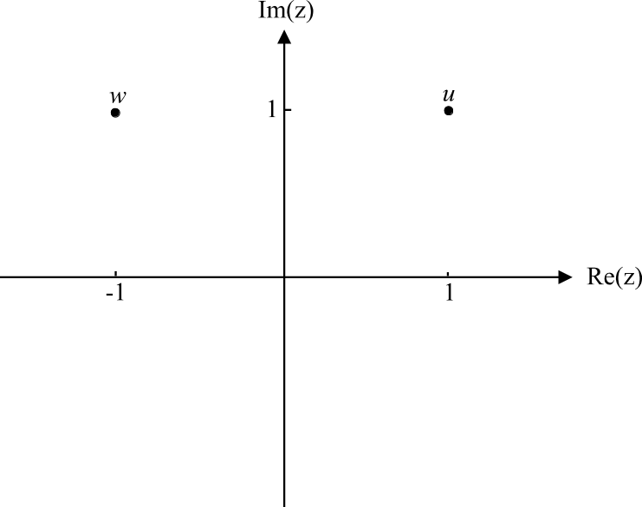

(1 mark)
Alternatively, 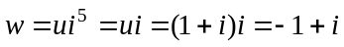

- Hence means use what you have just found therefore we must take a graphical rather than an algebraic approach.
We know that the roots of the equation 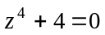 will be evenly spaced about the origin on the Argand diagram. (1 mark)
Given that u and w are roots and that there are two others, from the graph, they must be 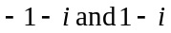.
(1 mark)

b. i. If mi is a solution to the equation 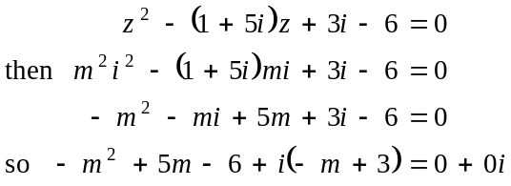
(1 mark)
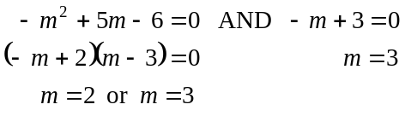
So 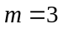 since the value of m must satisfy the real and imaginary parts.
(1 mark) for rejecting 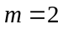

ii. Since 3i is a solution to the equation then 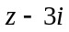 is a factor.
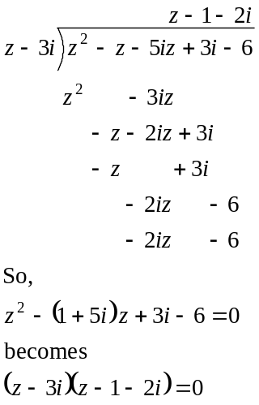
The solutions are 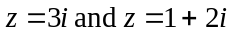
(1 mark)

c. i. The region defined by 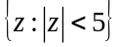 is a circle with boundary excluded and
with centre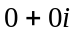 and radius units.
The region defined by 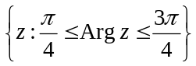 is a wedge with vertex at which is not included, and included boundaries with equations 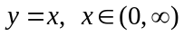 and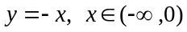. The region R is shown below.
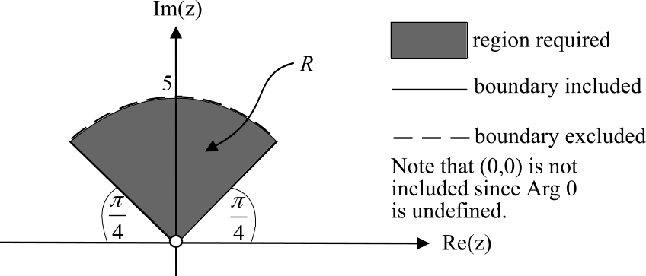

1 mark) for correct curved boundary
(1 mark) for correct straight line boundaries

ii. 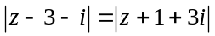
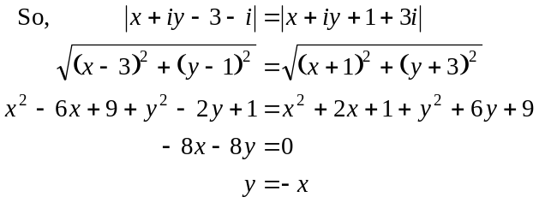
The region R is reflected in the line 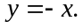 (1 mark)
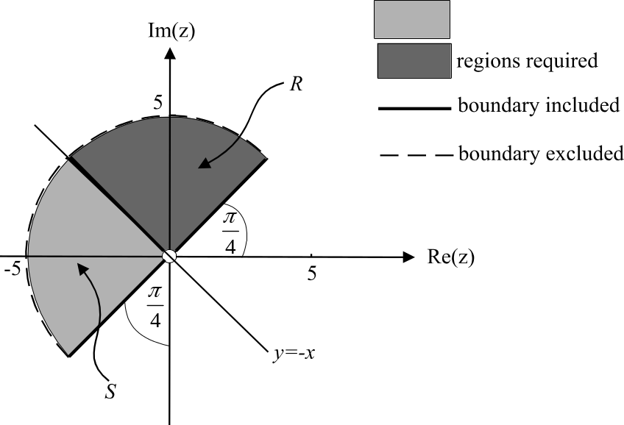

(1 mark) for correct shape and position of S

Total 12 marks
Question 2
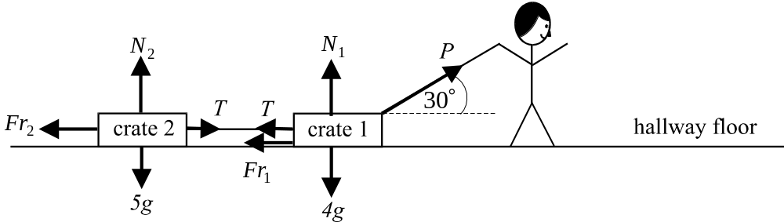
a.

(1 mark) for correct forces
around crate 1
(1 mark) for correct forces
around crate 2

b. 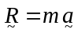
Using
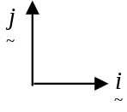

as our convention for direction we have, resolving around crate 1,
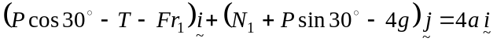 (1 mark)
Since 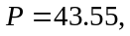 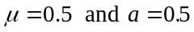,
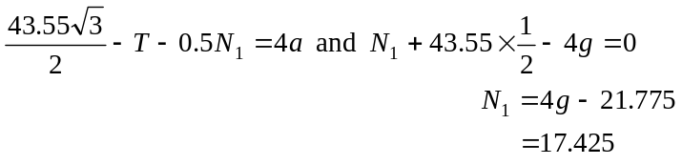
(1 mark)
So,
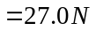 (correct to 1 decimal place) (1 mark)

c. Because Zac is accelerating at a constant rate of 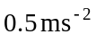, we can use the formula 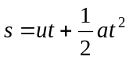 (1 mark)
where 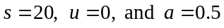
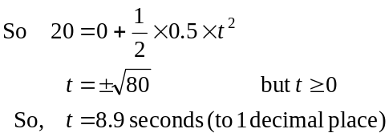
(1 mark)
d. The crates are on the point of sliding when 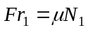.
Prior to that point, 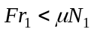. (1 mark)
Resolving around crate 1 and remembering that 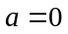 now, we have
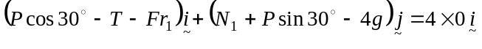
So,
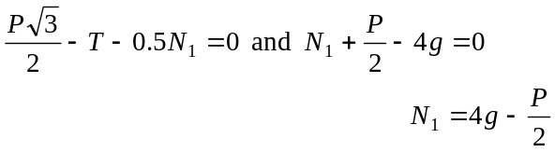
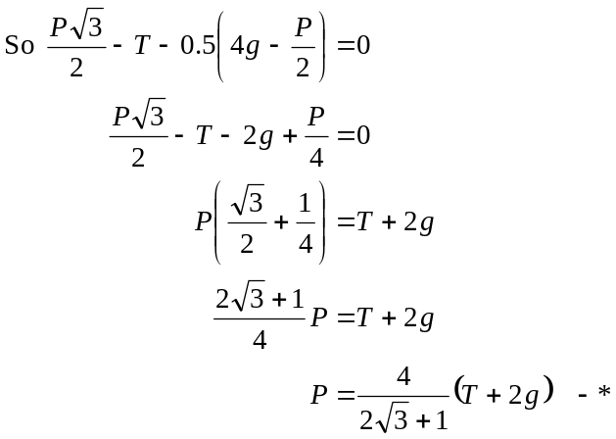
(1 mark)
Resolving around crate 2, we have
(1 mark)
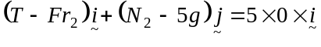
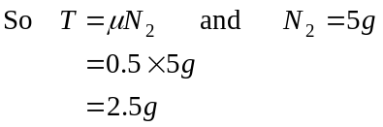
In *, gives
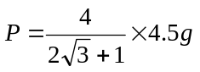
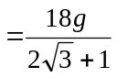 newtons
(1 mark)
Alternatively, a single equation can be used to solve this by considering the two crates as a single 9 kg entity.
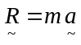
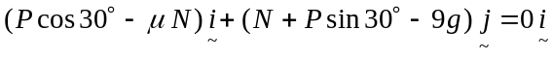
Equating components, we obtain 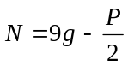
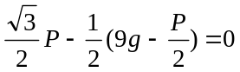
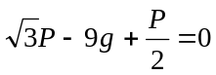
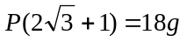 so, 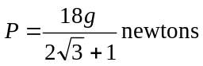

Total 11 marks
Question 3

a. For the function f to be defined, we require that
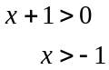
So the maximal domain of f is 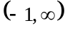.
(1 mark)
b.
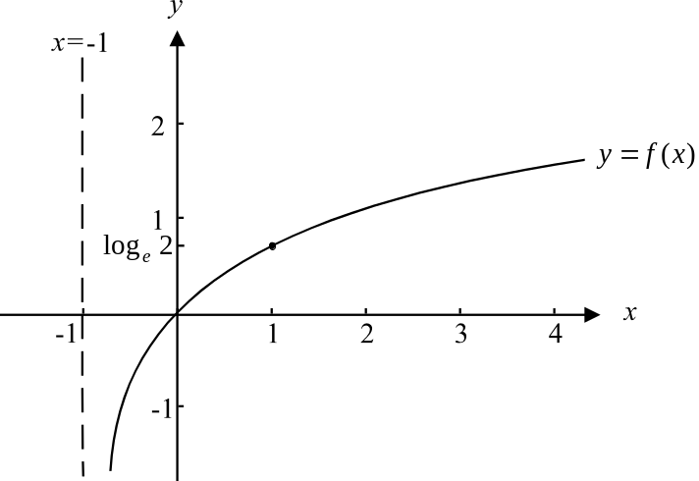

(1 mark)

c. The integral 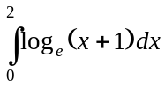 gives the area shaded in the diagram below.
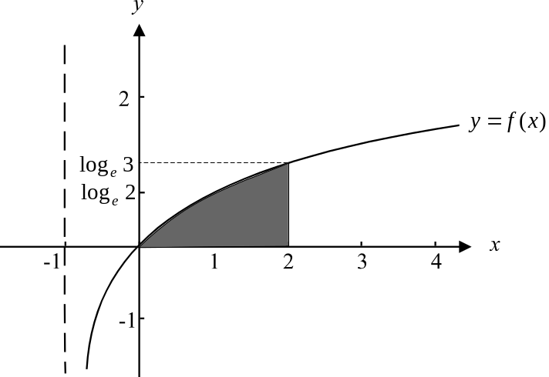

(1 mark)
The rectangle with corner points has an area given by 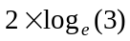. Clearly, the area of the shaded region is less than the area of the rectangle and hence 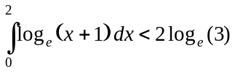.
(1 mark)

d. Following the same reasoning as in part c. we have
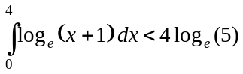, since the rectangle “surrounding” the area described by 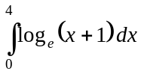 will have a width of 4 and a height of 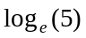.
(1 mark)
e. i.
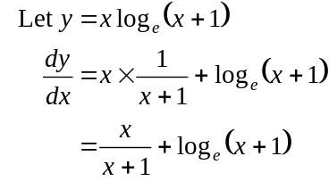
(1 mark)
ii.
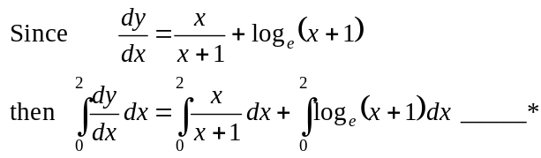
Method 1
Now, 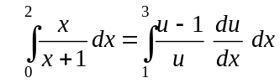
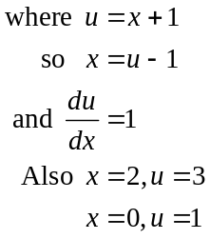
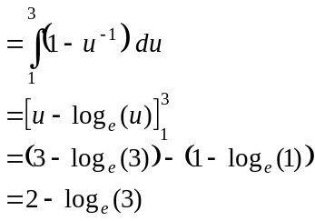
(1 mark)
Method 2
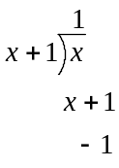
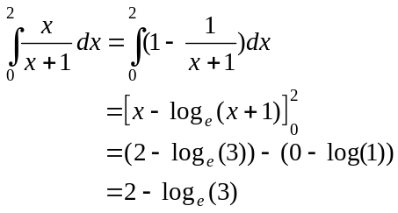
Using long division

So, * becomes
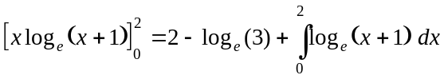
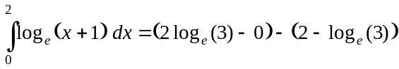
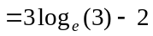
(1 mark)
f. Note that we are rotating about the y-axis and so the terminals must be on the y-axis.
When 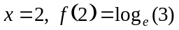 and similarly 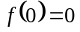.
Volume required 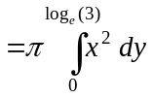
(1 mark) for terminals
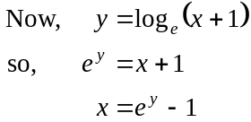
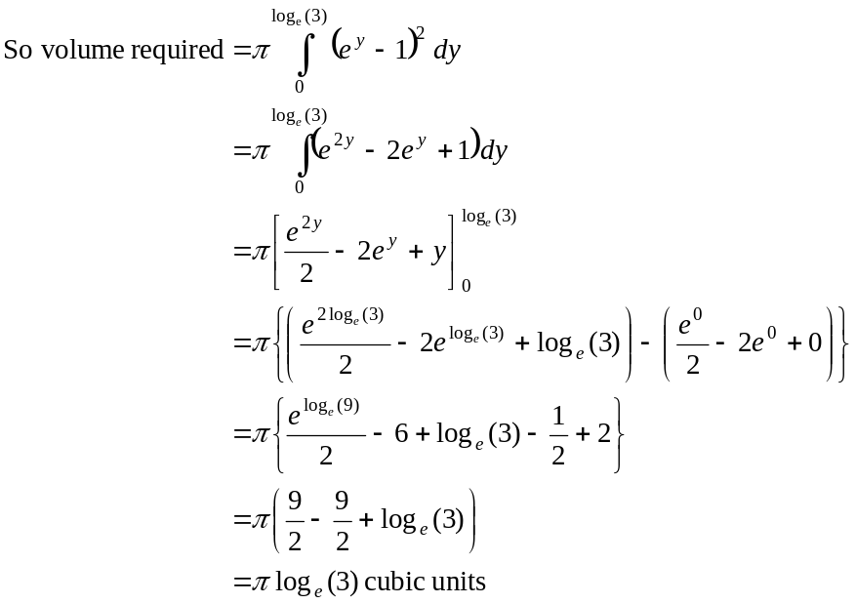
(1 mark) for integrand

Total 12 marks
(1 mark)
(1 mark)

Question 4
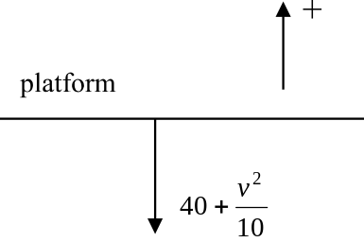
a. Take the origin to be that part on the
platform from which the particle is
projected. The downward forces acting
on the particle are the gravitational and
air resistance forces. Taking the positive
direction as upwards, and using the
equation of motion, 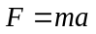we obtain
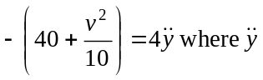is vertical acceleration.
So, 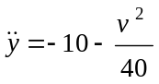 as required. (1 mark)

b. The maximum height is reached when 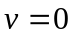.
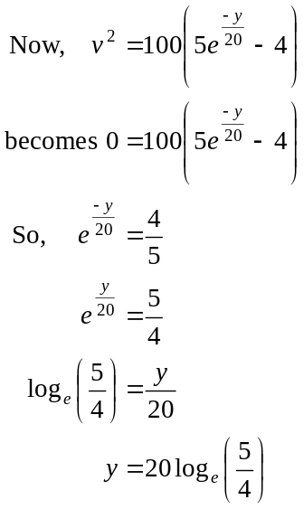
So the maximum height reached is 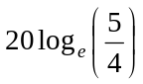 metres. (1 mark)

c. We need to consider the downward part
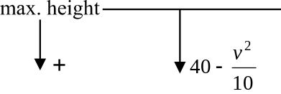
of the particle’s journey. Taking its
maximum height as the origin, the
downward direction as positive, and using
the equation of motion ,
we have 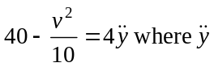 is
the vertical acceleration. So, 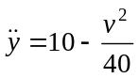 (1 mark)
Now, given that 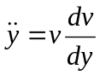
We have,
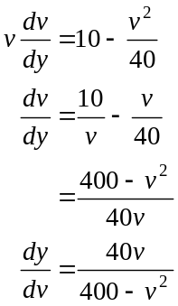

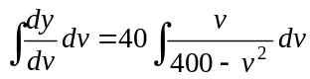
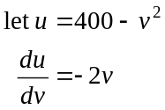
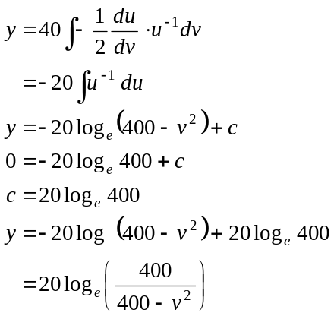
When y = 0,
v = 0
(1 mark)
From part b., the particle returns to the platform when it has travelled
metres. So, when 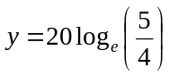
We have 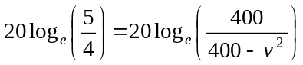
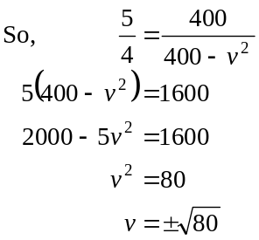
So, the particle is travelling at a speed of 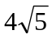 metres per second when it returns to the platform. (1 mark)

d. i. We need an expression for velocity as a function of time. Looking at
the motion of the particle from when it reached its maximum height, we have, from part c.
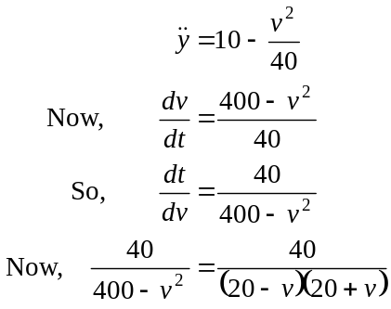
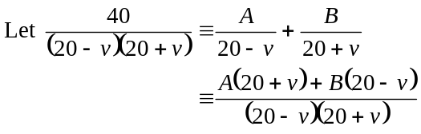
True iff 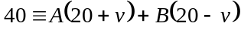
Put 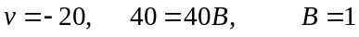
Put 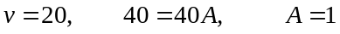
So, 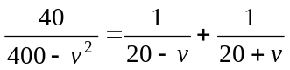
So, 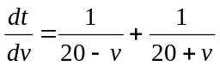 (1 mark)
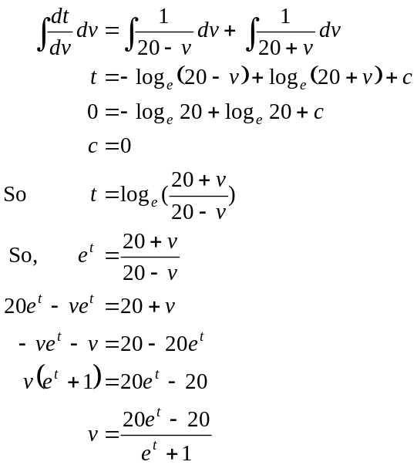
When t = 0, v = 0
(1 mark)
(1 mark)
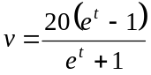
ii. Now,
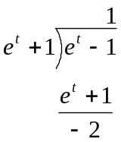
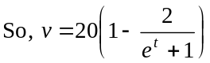 since

As, 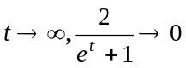
So, 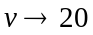 from below.
So the terminal velocity of the particle is 20 metres per second.
(1 mark)
e. For that part of the particle’s journey where it is falling downward, we have
from part d. that 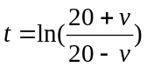.
From part c. the speed of the particle when it returned to the platform was
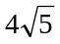 metres per second.
So when 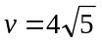, (since we assume that downwards is positive).
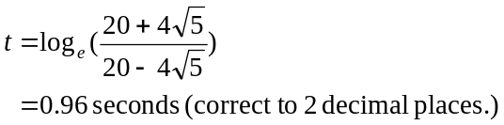
(1 mark)
Total 10 marks

Question 5

a. The naval exercise began when 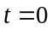
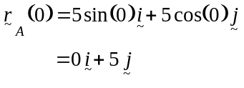
The aircraft carrier A was positioned 5 km due north of the fleet command ship when the exercise started.
(1 mark)

b. From a.
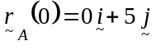
Also,
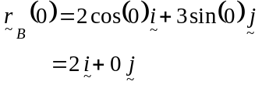
So aircraft carrier B is positioned 2 km due East of the fleet command ship.

So at the start of the naval exercise A and B
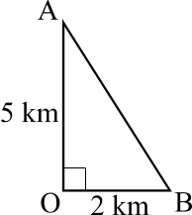
are as shown in the diagram
Distance required
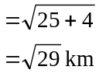
(1 mark)

c. 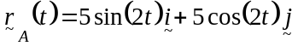
(1 mark)
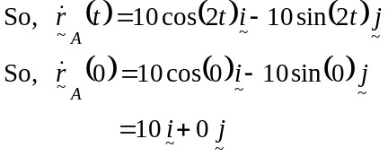
So the aircraft carrier A is moving due East when the naval exercise begins.
(1 mark)
d.
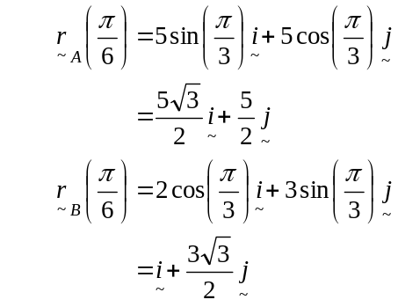
(1 mark)

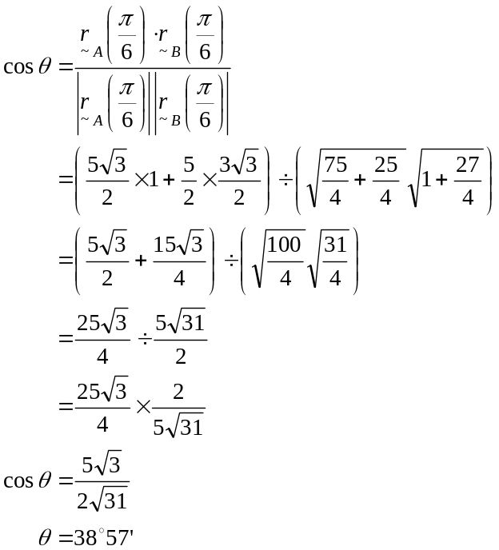
(1 mark)
So the required angle is 38°57’. (to the nearest minute) (1 mark)

e. i. 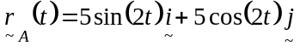
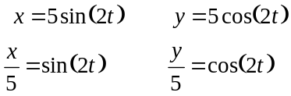
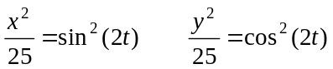
So, 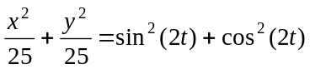
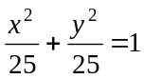
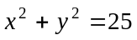
(1 mark)

ii. The path is circular with centre at O and a radius of 5 km. Also, we know from part c. that it is clockwise motion.
(1 mark)

f. Method 1 – “Hence…”
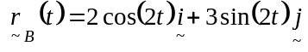
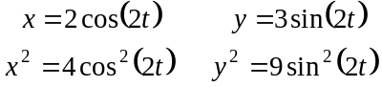
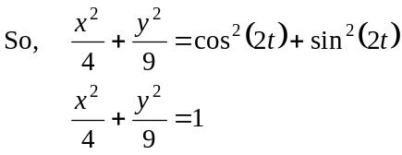
(1 mark)
The path of aircraft carrier B is that of an ellipse with a semi-minor axis length of 2 km and a semi-major axis length of 3 km and “centre” at O. From part e. we know that the path of aircraft carrier A is circular.
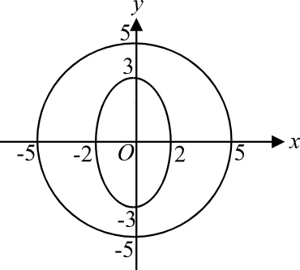
From the diagram, we see that
the two aircraft carriers cannot
collide.
(1 mark)

Method 2 – “Otherwise…”
The two aircraft carriers will collide iff
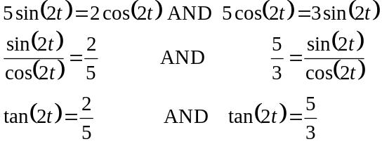
(1 mark)
Since this is not possible, that is the and components are not the same for both the carriers at the same point in time, then the two aircraft carriers cannot collide.
(1 mark)
g. i. The helicopter can only land on aircraft carrier A if they are at the same
position at the same time.
So, the helicopter can land on aircraft carrier A if
(1 mark)
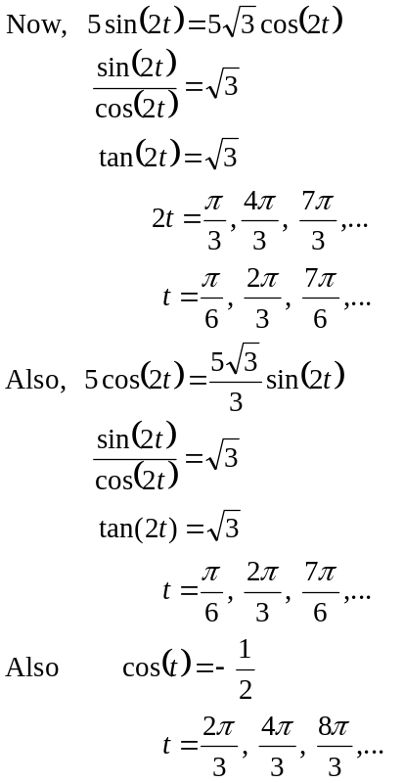
(1 mark) for examining each component
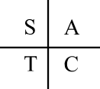
There are values of t (ie 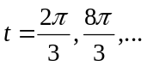) that satisfies all three position components. Therefore the helicopter and aircraft carrier A can be at the same position at the same time and hence the helicopter (barring technical difficulties) can land.
- Hence the least value of t when this happens is at 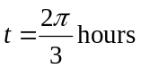.
(So, 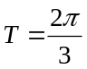.)
(1 mark)
h. Consider the vertical component of the position function of the helicopter.
Graph the function 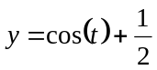.
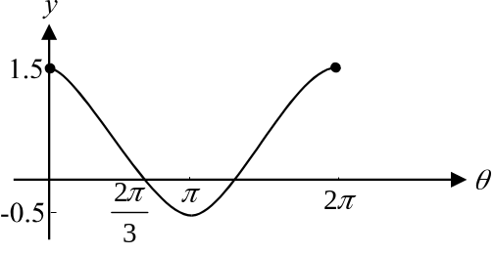
At 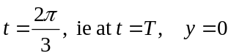.
For 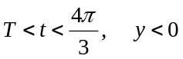.

This would mean that the helicopter would be under the water.
(1 mark)
Total 15 marks

